Los Angeles Community College District
CalWORKs Directors Retreat
Thursday, August 21, 2014 * 9:00 a.m. – 4:00 p.m. * Northridge, CA

~ Agenda ~

Welcome Blanca & Cece

Overview of day’s agenda Blanca

Leadership Training: What’s My Style? Heemanshu Bhagat, Trainer
Lunch

Budget Report Sorangel

2016 LACCD Accreditation All

DPSS & SBWIB Contract Renewals All

Future Professional Development Activities All

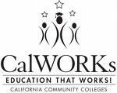
Closing Remarks Blanca, Cece & Abbey

